Welcome to project Girl Power Empowers
Meeting in Finland 2nd – 6th November 2025!

We are waiting totally 24 participants, from three countries: Finland, Denmark and Turkey. From every country there will be eight participants, five girls and three adults who are working in field of youth work or/and education.
The meeting is hold in Youth center Marttinen in Virrat.
Home | Nuorisokeskus Marttinen

Taxi will be waiting you in Parkana railway station Sunday 2nd November.

Accommodation is in log cottages/villas. Each country has its own cottage. The cottages have bedrooms for 2-3 people (no single rooms), a kitchen, a living room and a sauna. We eat breakfast, lunch and dinner in the main building of Marttinen, which is about a 10 minute walk away. We get snack bags or evening from dinner and eat in the cottages or in the evening program room.

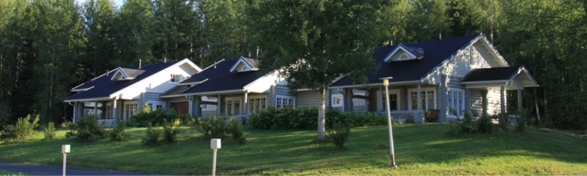

Most of our activities are hold in Antintalo (Antti´s house), near cottages. Some our activies are outdoors, so please prepare yourself with colthes suitable for the weather. At least we need to walk several times to dining area, even if it rains 😊. In Finland we keep saying that there is now bad weather, only bad clothing to weather!

Before camp young people from every countries have planned presentation of own homecountry and –municipality to cultural evening – and also presentation of some magnigicant woman, who has girl power.

Our activities during camp handles themes as get known myself, find own strengths and girl power.

Draft of program is below.
Working language in camp is English. Working and acting in foreign language can be more tiring than usual, but there will be breaks to rest or do school works in every day.

 | Sunday 2nd November | Monday 3rd November | Tuesdat 4th November | Wednesday 5th November | Thursday 6th November | Friday 7th November
8.00 |  | Breakfast | breakfast | breakfast | breakfast | breakfast
9.00 |  | Welcome to Marttinen! |  | standing up for yourself and | young people departure
 |  | Get to known each others | feel the power! | others | coordinators workshop | evaluation
 |  | rules, making safe place
12.00 |  | lunch | lunch | lunch | lunch | lunch
14.00 |  | feelings, girl power | feelings | dreams, hopes | coordinators workshop | departure
15.00 |  | who am I, who are we? | problem solving
 |  |  | resilience
17.00 | Arrival to venue | dinner | dinner | dinner | dinner
 | Dinner |  | relationships
 | Ice breakers, | cultural night | expectations | pancakes and bonfire
20.00 | get to know each others |  | sauna and jacuzzis
 |  |  | sausages and pancakes
22.00 | Good night! | Good night! | Good night! | Good night! | Good night!

What to bring with you:

- Clothes suitable to weather, warm and dry clothes to change (both indoors and outdoors)
- Your own hygienic products
- Your own medicines, if needed, discuss with your own worker, how to take those daily
- Swimming suit for sauna evening, jacuzzis and swimming
- Flashlight, headlamp
- Something to cultural evening

Weather in Finland in begin of November is usually quite cold, in area of Virrat and youth center Marttinen it is usually between –5 and +5 degrees (Celcius) – but it can also be colder or warmer and during week we probably will get same rain or snow. So please prepare yourself with hat, gloves and raincoat or umbrella!
You can check accurate weather before travel here: Weather for Virrat, FI - Forecaweather.com or whatever service you usually use. Municipality Marttinen is located is Virrat, Finland.
November is the darkest month in year, before we will get permanent snow cover. Youth Center Marttinen is located in very small municipality, practically in middle of nowhere so the darkness can surprise you. There is no need to be afraid, Finland is very safe country, but it is recommended to take own flashlight or headlamp with you. And of course, reflectors as well, so the car drivers can see you!

Workers from Finland, who will help you in every case

Satu Paasonen tel. +358 50 3118534 (050 3118534 when you call in Finland)
Maria Rinne tel. +358 50 311 8084
Ilona Kivelä tel. +358 40 626 4556

Emails: firstname.lastname@jyvaskyla.fi

